WATERPROOFING OF SURFACES

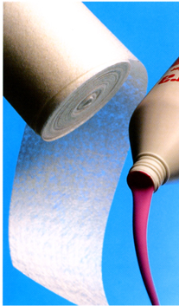
Complete waterproofing
of damp and wet areas
in bathrooms, washrooms
and shower areas

How to apply pages 1 & 2
Step-by-step guide to applying the tanking system

Application areas page 3
Diagrams to illustrate the recommended areas tor waterproofing

The Products page 3
Mira Tanking System - the products you need for successful washroom waterproofing

WATERPROOFING OF SURFACES
How to apply - Waterproofing of wall surfaces

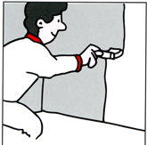 | 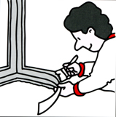 | 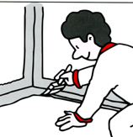
All absorbent surfaces (plasterboard, (ibreboard, brickwork, etc) should be primed with 1 coat ol 4120 sealer diluted with water (1:3). | Cover all joints, edges and corners with 100mm wide safecoat strip pressed into a coal of 4400 multicoat. Screws in plasterboard should also be covered with 4400 multicoat | The safecoat strips should be covered with another coat of 4400 multicoat, ensuring thai it is fully covered and absorbed. The 4400 multicoat should extend 100mm up the wall.
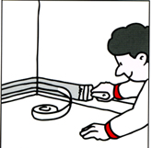 | 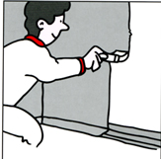 | 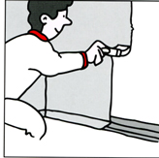
Behind a joint to floor vinyl there should be a strip of safecoat sealed with 44DO multicoat. | In the 'wet-zone' (see diagram on back page) a minimum ol 1mm (!.25kg/nv) 4400 multicoat should be applied. If applying more than one coat, the first should be dry before the next is applied. | In the 'damp-zone' (see diagram on back page) a minimum 1GOg/m: of 4120 sealer should be applied.
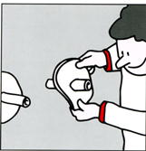 |  | 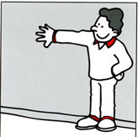
Around pipes use the self-adhesive safecoat manchet. Cut a hole in the 'manchef using the printed circles as guide. The hole should be slightly smaller than the outside diameter of the pipe. Place the 'rancher over the pipe and push rt firmly against the surface. | After fitting the salecoal manchEt, firmly spread 4400 multicoat so that it is fully covered and the material is saturated. | The drying time for water proof ing will in the depend on room temperature and humidity.  As a guide  4400 multicoat appro* 12hrs  4120 sealer 1-2 hrs

WATERPROOFING OF SURFACES

How to apply - Waterproofing of floor surfaces

 | 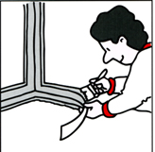 | 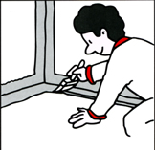
Prime all cement based surfaces with 1 coat o!4120 sealer diluted with water. 1:3. Do not prime plywood surfaces. | At the door/wall joint use the 100mm safecoat strip pressed into a covering of 4400 multicoat. | Cover the safecoat strip with a further coat of 4400 mutticoat, ensuring that it is fully covered. The 4400 multicoat should extend 100mm up the wall.
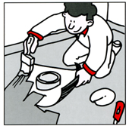 | 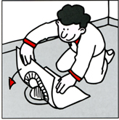 | 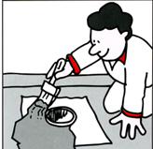
Around pipes Ihe appropriate safecoat manchel should be used. Cut a hole in the 'manchet' slightly smaller than the diameter of the pipe, place the 'manchel' over Ihe pipe and press down firmly against the floor. After fitting saturate the 'manchet' with 4400 Multicoat. | Floor drains should be sealed using the large 'manchet', which features a sell-adhesive central area. After positioning the 'manchet' around the drain aperture the surrounding material should be bedded in a layer of 4400 multicoat, and sealed with a further coat, ensuring full coverage and saturation.
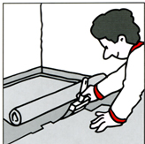 | 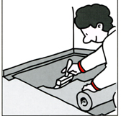 | 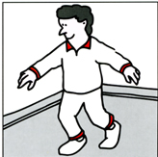
Start to coal the floor with 4400 multicoat and simultaneously cover with salecoat. rolling the material into the coating. | A second coat of 4400 multicoat should be immediately applied to the safecoat making sure that the material is fully covered and saturated. To check for complete waterproofing of the surface ensure that no traces of the original white colour of the salecoat remain. | Allow the 4400 multicoal approximately 12 hours to dry (depending on room temperature and humidity) before any further surface treatment.

WATERPROOFING OF SURFACES
Application areas

The diagrams illustrate the extent of the 'wet-zone' and the "damp-zone" in a bathroom, washroom and shower area.  The recommended degree of waterproofing is based on these defined areas.  MB. In Denmark, and other countries, approved water-proofing is a legal requirement.  The wall area behind the tiandbasin is only regarded as "wet-zone" if the basin is fitted with a shower. | 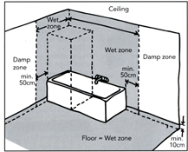
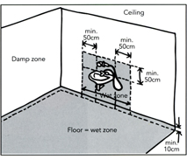 | 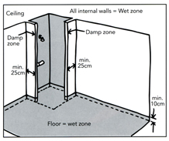

The Products
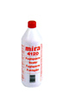 | Mira 4120 Sealer  Liquid, Acrylic based solution with red  colouring. Recommended as a primer in  'dry-room' areas, (diluted on porous and  concentrated on wooden surfaces.) Also  recommended as a waterproofing coaling for  walls in tne 'darnp-zone' in 'wet rooms'.  Usage: Concentrated - 1kg cover 5-7m² Thinned  Withwater in ratio 1:3(sealer:water)- 1kg covers 8-12m | 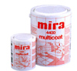 | Mira 4400 Multicoat  Neoprene bases, thick liquid membrane tor 100% waterproofing of all floor and wall surfaces in the 'wet zone'. Applied to the surface with brush or roller. Also to Be used for waterproofing of wall/floor join, corners, wall joints, apertures, etc in the 'wet room'.  Usage: Floors min 1.5kg/m' Walls min. 1.25kg/m'
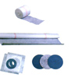 | Mira Safecoat/Seal Manchets  Salecoat rolls are used with 4400 Multicoat when waterproofing floors, loints, corners, and are now available in 3 sizes. The Seal Manchets are used similarly with 4400 Multicoat for the sealing of pipe and drain apertures. The large square manchet has a 125mm diameter cut oli! with a self adhesive central area and the small 125mm round manchet is completety self adhesive with circles marked for cutting holes 10-50mrn diameter.

