TILE BACKER BOARDS

tile backer boards
Specifiers guide to Dukkaboard™ tiling elements An economical and cost saving material

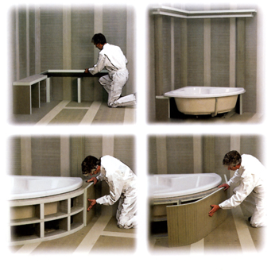 | Product details and benefits page 2  Pipe cladding....................... page 4  Wall lining applications........ page 5  Flooring applications........... page 6  Working with Dukkaboard™ . page 8

TILE BACKER BOARDS

A tile backing you can rely on  Tiling practice today is demanding. Designers want scope, contractors need speed and satisfied clients are paramount. Dukkaboard delivers even/time.  Manfactured to the highest specification, Dukkaboard™ is the benchmark for dimensionally stable, impervious and durable tiling boards. Shower or steam room, house or hotel, Dukkaboard™ is the safe choice. Common installation failures due to water ingress or unsuitable materials such as plywood or plasterboard are banished to the past.  The strength of Dukkaboard sheets is the composite construction. The hard extruded foam core is reinforced both sides with a fibreglass mesh and special mortar. Strong and lightweight, Dukkaboard™ is recommended for use over any substrate or construction. No longer is it necessary to render and plaster new walls or remove old tiles or plaster. Use Dukkaboard'" and tiling can start straight away.  Create partitions, insulate a floor for electrical underfloor heating, or make a bath panel - Dukkaboard'" is the versatile board for all tiling. Only imagination can limit the use of Dukkaboard™.  Unique benefits  * Lightweight  Easy to transport and handle. No extra static load requirements when used on timber floors, balcony roofs and attic conversions.  * High stability  Suitable for heavy duty applications. Dimensionally stable. Com press ive strength; approx 0.25 N/mm², with tile 2.5N/mm².  * Impervious to Moisture  Remains dimensionally stable, even in high humidity situations, does not rot. Water intake approx 0.5 vol. % after 28 days storage under water.  * Insulation  Minimal heat transfer to adjacent materials e.g. at window sills, ground bearing concrete slabs and external applications. K value 0.03W/m²K.  * Workability  Quick and simple to work with. Easy to create curves and profiles. Time saving = cost saving.  * Versatile  Suitable for use on metal and timber studwork, or on existing floors and walls to cover unstable and uneven surfaces. | 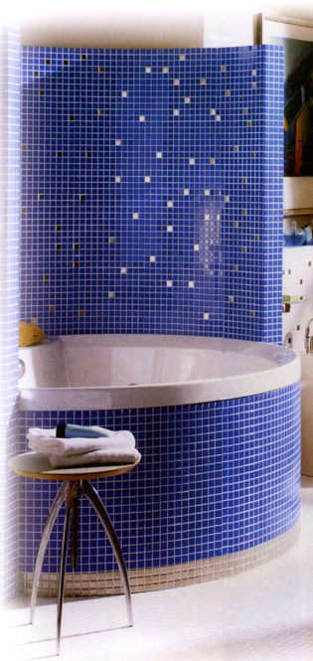

TILE BACKER BOARDS

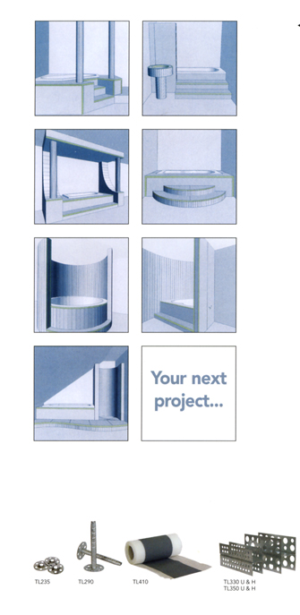 | Limitless design possibilities  These illustrations just give an idea of what can be achieved using Dukkaboard™.
  Dukkaboard™ | stock formats
  Dukkaboard"" is available in the
  following sizes:
  Thickness | Length | Width
  mm | mm | mm
  4 | 600 | 600
  6 | 1250 | 600
  10 | 2500 | 600
  12 | 2500 | 600
  20 | 2500 | 600
  30 | 2500 | 600
  40 | 2500 | 600
  50 | 2500 | 600
  80 | 2500 | 600
  Accessories
  Ref. | Description
  TL235 | 35mm 0 countersink fixing washer
  TL290 | 30x80mm stainless steel fixing dowel
  TL245 | 45mm drywall screw (other sizes also available)
  TL406 | Flexible adhesive for fixing and joining -Vitnflex 20Kg
  TL407 | Flexibond primer 5 litre
  TL410 | Neoprene waterproof tape 120rnrn x 50m
  TL411 | Self adhesive neoprene waterproof tape 100mm x 10m
  TL330 U | U profile mounting bracket 30rnm
  TL330 H | H profile mounting bracket 30mm
  TL350 U | U profile mounting bracket 50mm
  TL350H | H profile mounting bracket 50mm
  Puracol | Polyurethane gunnable jointing adhesive 310ml
  TL500 | Self adhesive fibreglass
   | reinforcing scrim 100mm x 45mTile magnet sets 4 per set

TILE BACKER BOARDS

Pipe cladding  Pipe and pipe shaft cladding  Dukkaboard¹" pipe cladding sections can be pre-fabricated for fast installation and easy tiling around pipes and services.  Manufactured from waterproof Dukkaboard'"(minimum thickness 20mm), the pipe cladding is heat insulating and rot proof,  Dukkaboard'" pipe cladding is simple to install using Puracol adhesive and profile mounting brackets.  Illustration 1  Standard pipe cladding.  Illustration 2  Special constructions can be fabricated  on site to meet specific requirements.  Illustration 3  Diagonal pipes need much wider boxing, this can be sensibly combined with shelving elements to create additional space.  Access panels  Access panels can be simply cut into the cladding once the tiles are fixed using a pad saw or similar. The resulting panel can be secured using Tile Magnet Sets.  Wall lining applications  Wall covering - masonry  Surfaces in older buildings are often unsuitable for tiling and require time consuming preparation. Timber walls may need stabilising, uneven masonry could need patching or existing surface finishes may have to be removed. Dukkaboard¹" is the simple solution and can be installed directly over such surfaces. The tiling surface is decoupled from the background and the boards provide a movement free, ready-to-tile substrate. | 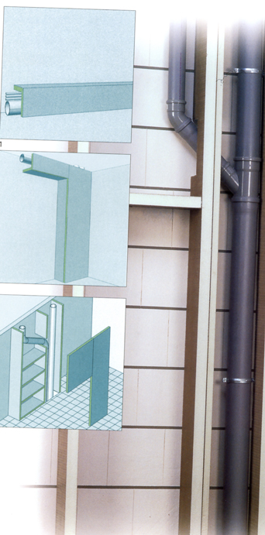

TILE BACKER BOARDS

Wall lining applications cont.
.
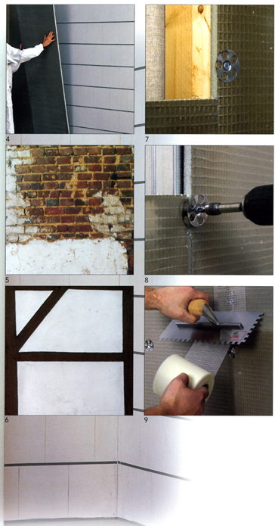 | Wall covering - masonry cont.  In new-build projects, Dukkaboard'" may make drylining or plastering of masonry unnecessary.  For most wall applications a minimum thickness of 12mm is recommended. However, 4mm and 6mm have particular benefits eg: 4mm can be used behind thin mosaics to bring them flush with the surrounding tiling, 6mm can be used to make flush prior to tiling over an old "tiled to dado height" wall.  Trowel size batches of Vitriflex adhesive are applied to the back of the boards which are then pressed to the wall and levelled up. Use TL290 Fixing Dowels as mechanical fixings which are applied through the batches into the masonry substrate. Approx 5-6 fixings per nV.  //lustration 4  Levelling out walls with Dukkaboard™. Trowel size batches of Vitriflex adhesive are applied to the boards and then pressed against the wall.  //lustrations 5 and 6 Mixed brick and timber walls and old flaking plaster are precarious surfaces for tiling. These can be made safe and sound with Dukkaboard  Wall covering - metal or timber studs  Dukkaboard'" is suitable for fixing directly onto metal or timber studwork. A minimum board thickness of 12mm is recommended with a maximum stud spacing of 300mm. All board edges must be supported. Boards should be screwed to the studs using countersink washers TL235 and either a drywall or self drilling screw. For example, when fixing Dukkaboard"¹ to studs spaced at 300mm, you wili need 16no. screws and washers per board. All joints are covered using either scrim tape TL500 or waterproof tapes TL410/TL411.  Illustrations 7 and 8  Use washers TL235 for fixing to timber or  metal studwork.  Illustration 9  Apply self-adhesive scrim tape TL500. For areas that are frequently wet use waterproof neoprene tape

TILE BACKER BOARDSing applications

Flooring applications
Dukkaboard¹" has many advantages over  conventional materials and methods both  in new and old buildings alike.  We recommend a minimum thickness of  10mm. Thicker boards may be used to  build up levels as an alternative to screed  or to improve thermal insulation.  See Thermonet brochure for more details.  • Uncouples problematic substrates [damaged, cracked dirty screeds and timber).  • No curing time necessary.  • Using Vitriflex adhesive, timber and screeded floors can be easily levelled when laying.  • Very light weight ensures easy transport and handling during work therefore producing time and cost savings.  • Water-resistant. Suitable for use in frequently wet areas and steam rooms.  • Heat insulating, suitable for use directly under electrical underfloor heating. Please note; Dukkaboard¹" should not be used on top of heating elements.  • High compressive strength and suitable for all types of tile.  Wooden floors  Dukkaboard'" is recommended for use over all types of timber floor. It provides an easy solution to the common problem of tiles failing on timber substrates due to moisture ingress and movement. Various institutes and standard associations disapprove of tiling on timber surfaces (without decoupling). With Dukkaboard™ these situations are taken care of.  Existing board or sheet flooring should be securely fixed. If using adhesive, prime floor using Flexibond TL407 diluted 1:5 with water. Coverage 40m²/L Vitriflex can be used to level out any uneven surface whilst laying boards. Bed Dukkaboard'" on a ribbed bed of Vitriflex TL406 and fix once Vitriflex has set using countersink washers TL235 and a drywall screw of suitable length: 9/10 fixings per m². All joints should be staggered and taped with either scrim tape TL500 or waterproof tape TL41Q/TL411 depending on the room application. | 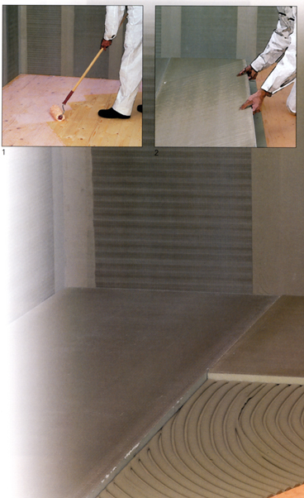

TILE BACKER BOARDS

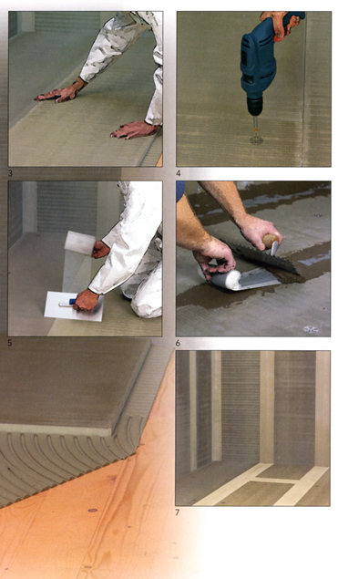 | Screeds  Existing floors that are dirty, cracked or painted can be successfully tiled after installing Dukkaboard™.  Boards are laid in a staggered joint pattern onto a ribbed bed of Vitriflex adhesive TL406. Any uneveness in the floor can be made good when trowelling out the adhesive. For boards of 40mrn or thicker used as an alternative to screed, a spot dab fixing method at 300mm centres may be used. All joints are taped with either scrim tape TL500 or waterproof tape TL410ATL411 depending on the room application.  Sub floor movement joints must be maintained through the Dukkaboard™ and final floor finish.  Illustration 1  Applying TL407 Flexibond to a timber  surface with a roller.  Illustration 2 and 3  Laying Dukkaboard™ onto TL406 Vitriflex mortar, the adhesive serves to level out any uneveness of the substrate.  Illustration 4  Mechanically fixing with screws and TL235 washers. When fixing to screed/ concrete floors, TL406 Vitriflex adhesive is sufficient.  /(lustrations 5 and 6  Application of TL500 self adhesive tape to reinforce joints... or for wet zones, such as bathrooms and shower rooms, apply TL410 waterproofing tape & adhesive.  Illustration 7  Preparation of the walls and floor is  complete, the room is ready for tiling.

TILE BACKER BOARDS

Working with Dukkaboard™

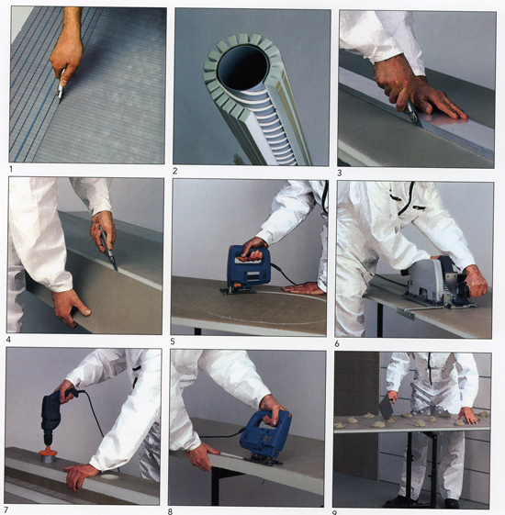
Illustrations 1 and 2  Manufacturing of pillars by glueing previously cut Dukkaboard with silicons to a plastic pipe.  Illustrations 3 and 4  Cutting boards with a trimming knife or equivalent. | Illustration 5  Jigsaws are very useful for circular cut  outs for basins etc.  Illustration 6  A circular saw can be used for exact cuts or mitres. | Illustration 7  Holes for pipes can be made with a hole cutter.  Illustration 8  Mitre cut with a jigsaw.

TILE BACKER BOARDS

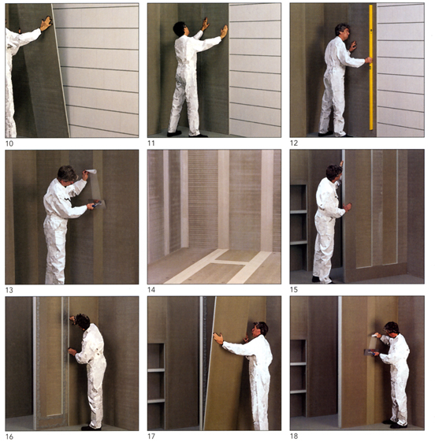
Illustrations 9-14  Preparing flat surfaces on walls with Dukkaboarcf." Trowel size batches of Vitriflex Mortar are applied to the back of the boards at approx. 30 cm centres. After sticking the boards to the wall they are levelled out using a spirit level. Joints are reinforced with Dukkaboard'" reinforcing tape. | Illustrations 15-18  Reinforced partloning using 50mm Dukkaboard⁷" as support uprights and cladding with 30mm Dukkaboard

